ST. XAVIER’S COLLEGE

Maitighar, Kathmandu

(Affiliated to National Examinations Board)



**C- Working with Functions**

**Submitted by:**

Anwesh Shrestha

023NEB-729

Grade 12 “G”

**Submitted to:**

|  |  |
| --- | --- |
| Mr. Jaya Sundar Shilpakar  (Lecturer) |  |
| Department of Computer | |

Lab Assignment: C Programming (Working with Functions)

## Write a C program to find the square of a given number using user defined functions. Define three functions, take input from the user using one function, calculate a square in another function and display the result in another function.

#include <stdio.h>

int num, square;

void square_input();

void square_compute();

void square_print();

void main() {

    square_input();

    square_compute();

    square_print();

}

void square_input() {

    printf("Kindly input your arbitrary number: ");

    scanf("%d", &num);

}

void square_compute() {

    square = num * num; // Use the global variable square

}

void square_print() {

    printf("The square of %d is %d\n", num, square);

}

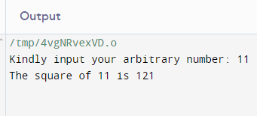

## Write a C program to calculate the area of the circle using a function.

#include <stdio.h>

float pi(float a);

float radius;

float area;

int main(){

printf("Enter the Radius of the Cricle: ");

scanf("%f", &radius);

area = pi(radius);

printf("The area of the circle is %f", area);

return 0;

}

float pi(float a){

int temp_holder;

temp_holder = 3.14*a*a;

return temp_holder;

}

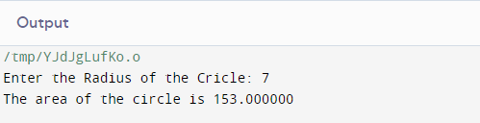

## Write a C program to calculate simple interest using a function.

#include <stdio.h>

float p, r, t;

void input_value();

float calculate_interest(float a, float b, float c);

void main(){

  input_value();

  float interest = calculate_interest(p, r, t);

  printf("The simple interest for Rs %f at %f for %f = %f", p, r, t, interest);

}

void input_value(){

  printf("Enter the Principle, Rate and Time: ");

  scanf("%f %f %f",&p,&r,&t);

}

float calculate_interest(float a, float b, float c){

  return (a * b * c) / 100;

}

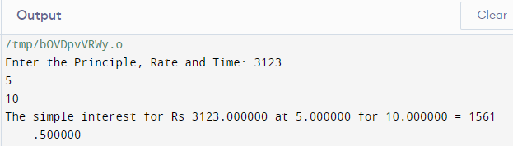

## Write a C program to find the sum of N natural numbers using function.

#include <stdio.h>

int sum()

{

  int i = 1, sum = 0, n;

  printf("Enter the number: ");

  scanf("%d", &n);

  for(i=1; i<=n; ++i)

  {

    sum += i;

  }

  return sum;

}

void main(){

  int T_sum = sum();

  printf("The sum of is %d", T_sum);

}

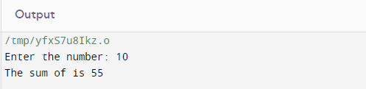

## Write a C program to return the absolute value of a number using a user-defined function.

  #include <stdio.h>

  int num;

  int absolute(int a);

  void main(){

    printf("Enter a number: ");

    scanf("%d", &num);

    int absolute_value = absolute(num);

    printf("The absolute value of %d is %d", num, absolute_value);

  }

  int absolute(int a)

  {

    if (a < 0)

    {

      return -a;

    }

    else

    {

      return a;

    }

  }

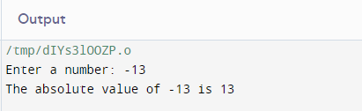

## Write a C program that reads a single lowercase character and returns the uppercase equivalent using a user-defined function.

#include <stdio.h>

char to_uppercase(char c);

int main() {

    char lower, upper;

    printf("Enter a lowercase character: ");

    scanf("%c", &lower);

    upper = to_uppercase(lower);

    printf("The uppercase equivalent of %c is %c\n", lower, upper);

    return 0;

}

// copied code

char to_uppercase(char c) {

    if (c >= 'a' && c <= 'z') {

        return c - 'a' + 'A';

    } else {

        return c;

    }

}

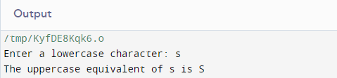

## Write a C program to swap two numbers using a function.

#include <stdio.h>

void swap(int a, int b);

int main() {

    int num1, num2;

    printf("Enter first number: ");

    scanf("%d", &num1);

    printf("Enter second number: ");

    scanf("%d", &num2);

    printf("Before swapping: num1 = %d, num2 = %d\n", num1, num2);

    swap(num1, num2);

    return 0;

}

void swap(int a, int b) {

    int temp;

    temp = a;

    a = b;

    b = temp;

    printf("Inside swap function: a = %d, b = %d\n", a, b);

}

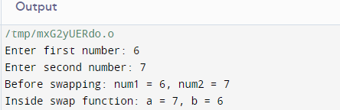

## Write a C program to check whether the given number is Odd or Even using a function.

#include <stdio.h>

void check_even_odd(int num);

int main() {

    int number;

    printf("Enter a number: ");

    scanf("%d", &number);

    check_even_odd(number);

    return 0;

}

void check_even_odd(int num) {

    if (num % 2 == 0) {

        printf("%d is even\n", num);

    } else {

        printf("%d is odd\n", num);

    }

}

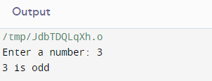

## Write a C program to check if the input number is perfect or not.

#include <stdio.h>

int is_perfect(int num);

int main() {

    int number;

    printf("Enter a number: ");

    scanf("%d", &number);

    if (is_perfect(number)) {

        printf("%d is a perfect number\n", number);

    } else {

        printf("%d is not a perfect number\n", number);

    }

    return 0;

}

int is_perfect(int num) {

    int sum = 0;

    if (num <= 1) {

        return 0;

    }

    for (int i = 1; i <= num / 2; i++) {

        if (num % i == 0) {

            sum += i;

        }

    }

    return sum == num;

}

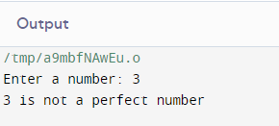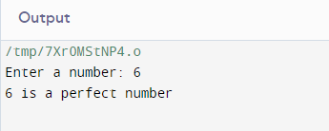

## Write a C program to find the maximum and minimum values in given three numbers. Use two separate functions for maximum and minimum.

#include <stdio.h>

int find_max(int a, int b, int c);

int find_min(int a, int b, int c);

int main() {

int num1, num2, num3;

printf("Enter three numbers: ");

scanf("%d %d %d", &num1, &num2, &num3);

int max = find_max(num1, num2, num3);

int min = find_min(num1, num2, num3);

printf("Maximum value: %d\n", max);

printf("Minimum value: %d\n", min);

return 0;

}

int find_max(int a, int b, int c) {

if (a >= b && a >= c) {

return a;

} else if (b >= a && b >= c) {

return b;

} else {

return c;

}

}

int find_min(int a, int b, int c) {

if (a <= b && a <= c) {

return a;

} else if (b <= a && b <= c) {

return b;

} else {

return c;

}

}

